**Screenshot of Task Performed**

SELECT * from teacher_details;

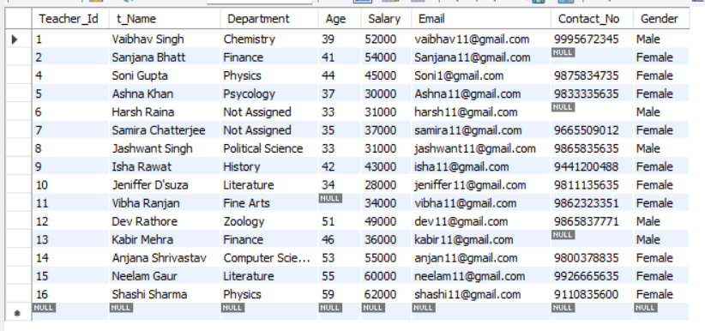

SELECT Sum(Salary) AS total_payroll from teacher_details;



SELECT AVG(Salary) AS avg_salary from teacher_details;



SELECT MAX(Salary) AS Max_Salary, MIN(Salary) AS Min_Salary from teacher_details;



SELECT COUNT(*) from teacher_details Where Gender='Female';



SELECT COUNT(*) from teacher_details Where Gender='Male';



Select Gender, AVG(Salary) AS avg_Salary from teacher_details

GROUP BY Gender;

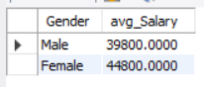

Select Department, AVG(Salary) AS avg_Salary from teacher_details

GROUP BY Department;

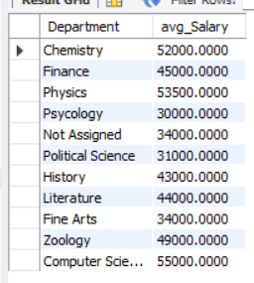

SELECT Department, MAX(Salary) AS Max_Salary FROM teacher_details

GROUP BY Department

HAVING MAX(Salary) > 50000;

